**Experiment 4**

**Lab Book:**

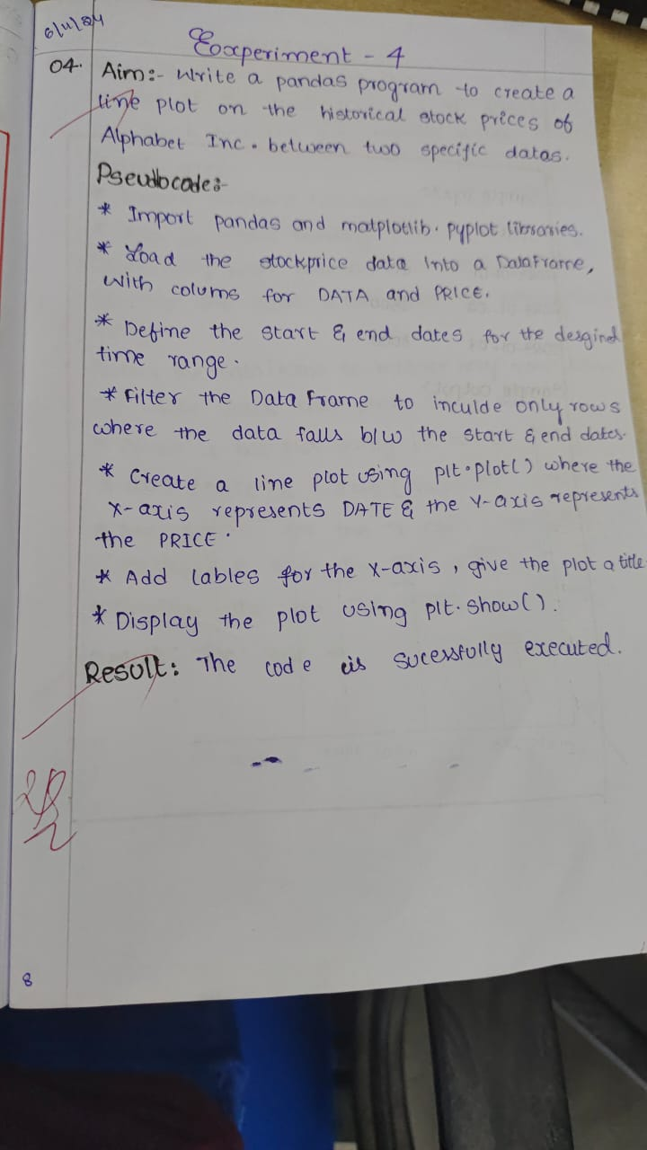

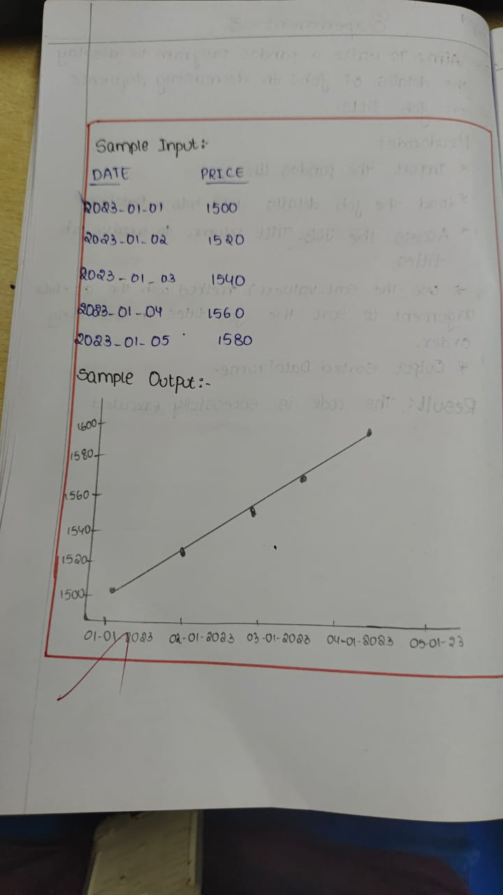

**Code:**

import pandas as pd

import yfinance as yf

import matplotlib.pyplot as plt

ticker_symbol = "GOOGL"

start_date = "2023-01-01"

end_date = "2023-12-31"

stock_data = yf.download(ticker_symbol, start=start_date, end=end_date)

plt.figure(figsize=(10, 6))

plt.plot(stock_data.index, stock_data['Close'], label="Closing Price", color="blue")

plt.title("Alphabet Inc. Stock Prices")

plt.xlabel("Date")

plt.ylabel("Closing Price (USD)")

plt.legend()

plt.grid(True)

plt.show()

**Sample Output**

